Fast**National University of Computer & Emerging Sciences, Karachi  
Fall 2019 CS-Department  
Mid-Term Exam  
23rd-Oct-2019, 08:10 am – 09:20 am**

|  |  |  |
| --- | --- | --- |
| **Course Code: CL-203** | **Course Name: Database Systems Lab** | |
| **Instructor Name: Ammara Yaseen** | | |
| **Student Roll No:** | | **Section: G** |

**Instructions:**

* Return the question paper.
* In case of any ambiguity, you may make assumption. But your assumption should not contradict any statement in the question paper.
* You are required to submit your exam in a single text file (Questions must be in order), name your file with your student id (k17-XXXX).

**Time:** 70 minutes. **Max Marks:** 50

**Q1-**

1. Find the total number of booking in the month of September.

SELECT COUNT(BOOKING_ID) FROM BOOKING WHERE INITCAP(TO_CHAR(BOOKING_DATE,'MONTH')) ='SEPTEMBER';

1. How many times the room *‘101’* booked by the guests.

SELECT COUNT(ROOM_NO) FROM BOOKING WHERE ROOM_NO=101;

**Q2-**Find the guest_id and number of rooms who booked more than one room (at the same or different timings).

SELECT COUNT(ROOM_NO), GUEST_ID FROM BOOKING GROUP BY GUEST_ID HAVING COUNT(ROOM_NO)>1;

**Q3-** List the arrival time and the first and last names (in single column) for all guests booked on

2016-11-03, order the output by time of arrival.

SELECT ARRIVAL_TIME, FIRST_NAME||' '||LAST_NAME AS NAME FROM GUEST, BOOKING WHERE

ID=GUEST_ID AND BOOKING_DATE=TO_DATE('03-11-2016','DD-MM-YYYY')

ORDER BY ARRIVAL_TIME;

**Q4-** Show the total amount payable by guest Lisa Nandy for her room bookings.

SELECT SUM(DAYS*AMOUNT) FROM BOOKING, RATE, GUEST WHERE UPPER(FIRST_NAME) ='LISA' AND

UPPER(LAST_NAME) ='NANDY' AND BOOKING.GUEST_ID=GUEST.ID AND

BOOKING.OCCUPANTS=RATE.OCCUPANCY AND RATE.ROOM_TYPE=BOOKING.ROOM_TYPE_REQUESTED;

**Q5-** Get guest name, room order by first name for all guests if room is not assigned then display "No Room Assigned".

SELECT ID, FIRST_NAME, NVL2(ROOM_NO, TO_CHAR(ROOM_NO),'NO ROOM ASSIGNED') FROM GUEST LEFT OUTER JOIN BOOKING ON (GUEST_ID = ID) ORDER BY FIRST_NAME;

**Q6-** For every guest who has the word “Edinburgh” in their address show the total number of days booked. Be sure to include ‘0’ for those guests who have never had a booking. Show last name, first name, address and number of nights. Order by last name then first name.

SELECT LAST_NAME, FIRST_NAME, ADDRESS, DAYS FROM GUEST LEFT OUTER JOIN BOOKING ON ID=GUEST_ID WHERE UPPER(ADDRESS) LIKE '%EDINBURGH%' ORDER BY LAST_NAME, FIRST_NAME;

**Q7-** Have two guests with the same surname ever stayed in the hotel? Show the last name and both first names.

SELECT FIRST_NAME, LAST_NAME FROM GUEST WHERE LAST_NAME IN (

SELECT LAST_NAME FROM BOOKING, GUEST WHERE GUEST_ID = ID GROUP BY LAST_NAME HAVING COUNT(LAST_NAME) > 1 AND COUNT (DISTINCT FIRST_NAME)! = 1);

**Q8**- Develop a logical and relational model of the same schema provided to you.

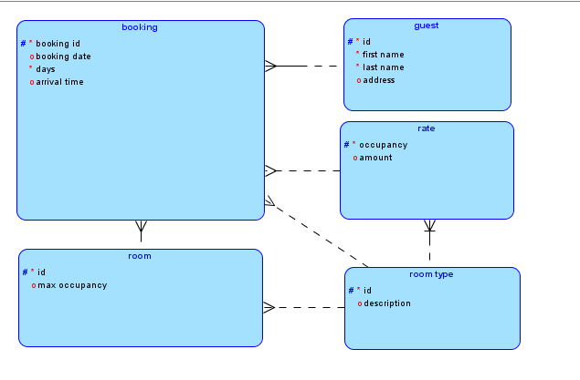

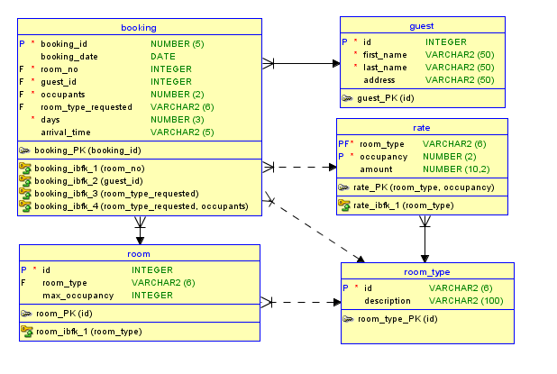

**Q9**-

1. Insert one record in each table of the given schema. Take user input while inserting in the guest table.

insert into room_type values ('3-bed','beatifully decorated');

insert into rate values ('3-bed',3,56.00);

insert into room values (200,'3-bed',3);

insert into guest values (&id,'&f_name','&l_name','&address');

insert into booking values (6001,to_date('2016-11-03','yyyy-mm-dd'),200,1027,3,'3-bed',5,'13:00');

1. As per the new policy rates of the room’s increases 50%.reflect this change in the database.

Update rate set amount=amount + (amount*0.5);

**Q10-**Write a Pl/Sql program that prints an asterisk (*) for every hundreds of the amount payable by the guests.

Sample Output:

|  |  |  |
| --- | --- | --- |
| **Guest Name** | **Amount Payable** | **Remarks** |
| Jack | 112 | * |
| Nick | 504 | ***** |
| ….. | … | … |
| ….. | … | … |

declare

amount_payable int;

f_name guest.first_name%type;

asteric int;

begin

SELECT SUM(DAYS*AMOUNT),first_name into amount_payable,f_name FROM BOOKING, RATE, GUEST WHERE UPPER(FIRST_NAME) ='&name' AND BOOKING.GUEST_ID=GUEST.ID AND

BOOKING.OCCUPANTS=RATE.OCCUPANCY AND RATE.ROOM_TYPE=BOOKING.ROOM_TYPE_REQUESTED GROUP BY FIRST_NAME;

asteric :=amount_payable/100;

dbms_output.put_line(f_name||' '||amount_payable);

for i in 1..asteric

loop

DBMS_OUTPUT.PUT_LINE(' '|| '*');

end loop;

end;

/

***BEST OF LUCK!***